**Blavatsky, Madame Helena Petrovna (1831–91)**

Helena Petrovna Blavatsky was a spiritualist, occultist, m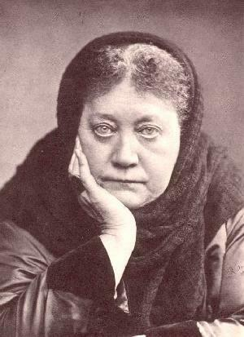edium, and the central figure of the Theosophical movement. Blavatsky, Colonel Henry S. Olcott, and William Quan Judge founded the Theosophical Society in 1875. Theosophy aimed to form a nucleus of the universal brotherhood of humanity, to encourage the study of comparative religion, philosophy, and science, and to investigate the unexplained laws of nature and the powers latent in man. The most important of Blavatsky’s writings is *The Secret Doctrine*, which aimed to synthesise science, religion, and philosophy.It is largely based on ‘The Book of Dzyan’, an ancient text which Blavatsky claimed to have seen while studying under occult masters in Tibet. Blavatsky’s writings and ideas have often been criticised for spurious claims and scholarship, reaching their pinnacle in a devastating report from the Society for Psychical Research in 1885 denouncing her as a fraud JAMES JOYCE’s *FINNEGANS WAKE* has many allusions to theosophy and Madame Blavatsky. Other prominent modernists with an interest in theosophy include W. B. YEATS and painter PIET MONDRIAN.

Photograph of Madame Blavatsky

from about 1894.

**List of works:**

Blavatsky, Helena P. (1888) *The Secret Doctrine: The Synthesis of Science, Religion, and Philosophy*. 2 vols., London: The Theosophical Publishing Company.

A large work of occultism which purports to reveal an ancient universal religion contained in ‘The Book of Dzyan’, several stanzas of which are contained in the two volumes. The text is not so much difficult as it is verbose and unrewarding.

**References and Further Reading**

Caldwell, Daniel H. (2000) *The Esoteric World of Madame Blavatsky: Insights into the Life of a Modern Sphinx*. Wheaton, IL: Quest Books.

This is a collection of personal and impersonal accounts of Madame Blavatky’s life, which manages to include a mix of positive and negative perspectives despite the fact that it is published by the Theosophical Publishing House.

Platt, Len (2008) ‘Madame Blavatsky and Theosophy in *Finnegans Wake*: An Annotated List’, *James Joyce Quarterly* 45 (2): 281-300.

A highly specified resource, but useful is giving some indications of how and why Theosophy was engaged with by an eponymous modernist like Joyce. Before the annotations proper there is a useful condensed discussion of Joyce and Theosophy.

**ROBERT KIELY, Birkbeck College, University of London**

**Source URL for image:**

**http://images.google.ca/imgres?q=madame+blavatsky&num=10&hl=en&biw=1024&bih=602&tbm=isch&tbnid=GdmdVFYxlb9GAM:&imgrefurl=http://blavatskyarchives.com/longseal.htm&docid=Mj2hOz-tHSawjM&imgurl=http://blavatskyarchives.com/hpbzoomb4.jpg&w=300&h=413&ei=S6UuUMDjKI6MyAGl1IHgDA&zoom=1&iact=hc&vpx=310&vpy=141&dur=61&hovh=263&hovw=191&tx=118&ty=142&sig=106983759535599720376&page=1&tbnh=115&tbnw=83&start=0&ndsp=23&ved=1t:429,r:2,s:0,i:93**